

**Advanced Web Programming Lab**

**BCSAW417**

|  |  |
| --- | --- |
| **Student Name** |  |
| **USN** |  |
| **Branch** |  |
| **Section/Batch** |  |
| **Faculty In-charge** |  |

**202X-202X**

Contents

1. Introduction 2

2. Objective 2

3. Technologies Used 2

4. Website Structure 3

5. Functionalities Implemented 3

6. Code Integration 4

HTML (index.html) 4

CSS (style.css) JavaScript (script.js) 5

7. Output Screenshot 6

8. Conclusion 6

# 1. Introduction

This report documents the development of a **Survey Form Website** designed to collect feedback from users. The project combines a clean design, functional interaction, and data management capabilities.

# 2. Objective

The main goal of this project was to create an interactive and responsive survey form that:

* Collects user data (Name, Email, Age Group, Feedback).
* Validates input fields.
* Displays submitted entries.
* Allows users to download their submitted data as a JSON file.

# 3. Technologies Used

* **HTML5** — For structuring the webpage.
* **CSS3** — For styling and responsive design.
* **JavaScript** — For form handling, dynamic display, and JSON file generation.

# 4. Website Structure

The website is divided into:

* **Header Section**: Title of the survey.
* **Form Section**: Input fields for Name, Email, Age Group, and Feedback.
* **Response Section**: Thank-you message and error messages.
* **Download Section**: Button to export collected data as JSON.
* **Display Section**: Shows all submissions dynamically.

# 5. Functionalities Implemented

* **Form Validation**: Ensures no field is left empty before submission.
* **Dynamic Data Display**: Submitted entries are shown below the form.
* **Download Feature**: Users can download all submitted data in JSON format.
* **Responsive Design**: Layout adjusts to various screen sizes.

# 6. Code Integration

### HTML (index.html)

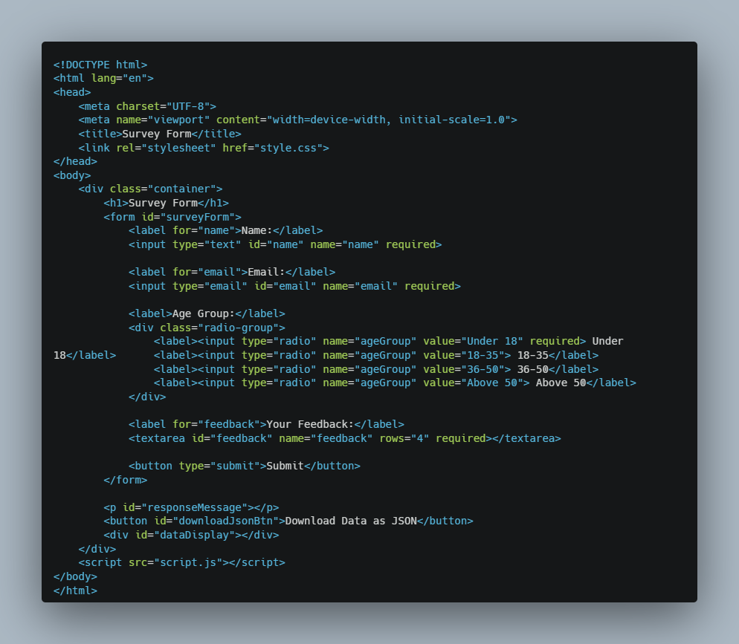

### CSS (style.css) JavaScript (script.js)

# 7. Output Screenshot

# 8. Conclusion

This project successfully demonstrates how a simple, user-friendly website can collect, validate, display, and export user feedback. Future improvements could include:

* Adding server-side storage.
* Advanced validation (Regex checks).
* Responsive improvements for smaller devices.
* Custom confirmation emails for users.